2602113666_LabAssignment1
Wilbert Chandra
March 29, 2023
Import Data
library(ggplot2)
data("msleep")
msleep
## # A tibble: 83 × 11
## name genus vore order conservation sleep_total sleep_rem sleep_cycle awake
## <chr> <chr> <chr> <chr> <chr> <dbl> <dbl> <dbl> <dbl>
## 1 Cheet… Acin… carni Carn… lc 12.1 NA NA 11.9
## 2 Owl m… Aotus omni Prim… <NA> 17 1.8 NA 7
## 3 Mount… Aplo… herbi Rode… nt 14.4 2.4 NA 9.6
## 4 Great… Blar… omni Sori… lc 14.9 2.3 0.133 9.1
## 5 Cow Bos herbi Arti… domesticated 4 0.7 0.667 20
## 6 Three… Brad… herbi Pilo… <NA> 14.4 2.2 0.767 9.6
## 7 North… Call… carni Carn… vu 8.7 1.4 0.383 15.3
## 8 Vespe… Calo… <NA> Rode… <NA> 7 NA NA 17
## 9 Dog Canis carni Carn… domesticated 10.1 2.9 0.333 13.9
## 10 Roe d… Capr… herbi Arti… lc 3 NA NA 21
## # ℹ 73 more rows
## # ℹ 2 more variables: brainwt <dbl>, bodywt <dbl>
User Defined Function to give basic summary
basicSummary <- function(df, dgts) {
m <- ncol(df) # column
varNames <- colnames(df)
varType <- vector("character", m)
topLevel <- vector("character", m)
topCount <- vector("numeric", m)
missCount <- vector("numeric", m)
levels <- vector("numeric", m)
for (i in 1:m) {
x <- df[,i]
varType[i] <- class(x)
xtab <- table(x, useNA = "ifany")
levels[i] <- length(xtab)
nums <- as.numeric(xtab)
maxnum <- max(nums)
topCount[i] <- maxnum
maxIndex <- which.max(nums)
lvls <- names(xtab)
topLevel[i] <- lvls[maxIndex]
missIndex <- which((is.na(x)) | (x == "") | (x == " "))
missCount[i] <- length(missIndex)
}
n <- nrow(df) # Rows
topFrac <- round(topCount/n, digits = dgts)
missFrac <- round(missCount/n, digits = dgts)
summaryFrame <- data.frame(variable = varNames,
type = varType,
levels = levels,
topLevel = topLevel,
topCount = topCount,
topFrac = topFrac,
missFraq = missCount,
missFrac = missFrac)
return(summaryFrame)
}

General Statistics
str(msleep)
## tibble [83 × 11] (S3: tbl_df/tbl/data.frame)
## $ name : chr [1:83] "Cheetah" "Owl monkey" "Mountain beaver" "Greater short-tailed shrew" ...
## $ genus : chr [1:83] "Acinonyx" "Aotus" "Aplodontia" "Blarina" ...
## $ vore : chr [1:83] "carni" "omni" "herbi" "omni" ...
## $ order : chr [1:83] "Carnivora" "Primates" "Rodentia" "Soricomorpha" ...
## $ conservation: chr [1:83] "lc" NA "nt" "lc" ...
## $ sleep_total : num [1:83] 12.1 17 14.4 14.9 4 14.4 8.7 7 10.1 3 ...
## $ sleep_rem : num [1:83] NA 1.8 2.4 2.3 0.7 2.2 1.4 NA 2.9 NA ...
## $ sleep_cycle : num [1:83] NA NA NA 0.133 0.667 ...
## $ awake : num [1:83] 11.9 7 9.6 9.1 20 9.6 15.3 17 13.9 21 ...
## $ brainwt : num [1:83] NA 0.0155 NA 0.00029 0.423 NA NA NA 0.07 0.0982 ...
## $ bodywt : num [1:83] 50 0.48 1.35 0.019 600 ...
basicSummary(msleep)
## Warning in varType[i] <- class(x): number of items to replace is not a multiple
## of replacement length
## Warning in varType[i] <- class(x): number of items to replace is not a multiple
## of replacement length
## Warning in varType[i] <- class(x): number of items to replace is not a multiple
## of replacement length
## Warning in varType[i] <- class(x): number of items to replace is not a multiple
## of replacement length
## Warning in varType[i] <- class(x): number of items to replace is not a multiple
## of replacement length
## Warning in varType[i] <- class(x): number of items to replace is not a multiple
## of replacement length
## Warning in varType[i] <- class(x): number of items to replace is not a multiple
## of replacement length
## Warning in varType[i] <- class(x): number of items to replace is not a multiple
## of replacement length
## Warning in varType[i] <- class(x): number of items to replace is not a multiple
## of replacement length
## Warning in varType[i] <- class(x): number of items to replace is not a multiple
## of replacement length
## Warning in varType[i] <- class(x): number of items to replace is not a multiple
## of replacement length
## variable type levels topLevel topCount topFrac missFraq
## 1 name tbl_df 83 African elephant 1 0 0
## 2 genus tbl_df 77 Panthera 3 0 0
## 3 vore tbl_df 5 herbi 32 0 7
## 4 order tbl_df 19 Rodentia 22 0 0
## 5 conservation tbl_df 7 <NA> 29 0 29
## 6 sleep_total tbl_df 65 12.5 4 0 0
## 7 sleep_rem tbl_df 33 <NA> 22 0 22
## 8 sleep_cycle tbl_df 23 <NA> 51 1 51
## 9 awake tbl_df 65 11.5 4 0 0
## 10 brainwt tbl_df 54 <NA> 27 0 27
## 11 bodywt tbl_df 82 1.1 2 0 0
## missFrac
## 1 0
## 2 0
## 3 0
## 4 0
## 5 0
## 6 0
## 7 0
## 8 1
## 9 0
## 10 0
## 11 0
table(msleep$conservation)
##
## cd domesticated en lc nt vu
## 2 10 4 27 4 7
table(msleep$sleep_rem)
##
## 0.1 0.4 0.5 0.6 0.7 0.8 0.9 1 1.1 1.2 1.3 1.4 1.5 1.8 1.9 2 2.1 2.2 2.3 2.4
## 1 3 2 4 2 1 3 2 3 1 1 5 3 2 2 3 1 2 2 5
## 2.6 2.7 2.9 3 3.1 3.2 3.4 3.5 3.9 4.9 6.1 6.6
## 1 1 1 1 2 1 1 1 1 1 1 1
table(msleep$sleep_cycle)
##
## 0.116666667 0.133333333 0.15 0.166666667 0.183333333 0.2
## 2 1 2 1 3 2
## 0.216666667 0.233333333 0.283333333 0.333333333 0.35 0.383333333
## 2 1 1 2 1 2
## 0.416666667 0.5 0.55 0.666666667 0.75 0.766666667
## 2 1 1 2 1 1
## 0.9 1 1.416666667 1.5
## 1 1 1 1
table(msleep$brainwt)
##
## 0.00014 0.00025 0.00029 3e-04 0.00033 4e-04 0.001 0.00118 0.0012 0.0019
## 1 1 1 1 1 1 2 1 1 1
## 0.0024 0.0025 0.0026 0.003 0.0035 0.004 0.005 0.0055 0.0057 0.0063
## 1 1 1 1 1 1 1 1 1 1
## 0.0064 0.0066 0.0108 0.0114 0.0121 0.01227 0.0123 0.0125 0.0155 0.0175
## 1 1 1 1 1 1 1 1 1 1
## 0.02 0.021 0.025 0.0256 0.0445 0.0504 0.07 0.081 0.0982 0.115
## 1 1 1 1 1 1 1 1 1 2
## 0.157 0.169 0.175 0.179 0.18 0.325 0.419 0.423 0.44 0.655
## 1 1 1 1 2 1 1 1 1 1
## 1.32 4.603 5.712
## 1 1 1
From the table and descrition above we can see that the msleep dataset have 83 Objects and 11 Variables which is
- name : Categorical data with 83 unique values with each unique values having occuring 1 times. With no missing values
- genus : Categorical data with 77 unique values with “Pantera” being the most occuring value, occuring 3 times. With no missing values.
- vore : Categorical data with 5 unique values with “herbi” being the most occuring value, occuring 32 times. With no missing values.
- order : Categorical data with 19 unique values with “Rodentia” being the most occuring value, occuring 22 times. With no missing values.
- conservartion : Categorical data with 7 unique values with “lc” being the most occuring value ignoring missing value, occuring 27 times. With 29 missing values.
- sleep_total : Numerical data with 65 unique values with “12.5” being the most occuring values, occuring 4 times. With no missing values.
- sleep_rem : Numerical data with 33 unique values with “1.4” being the most occuring value ignoring missing value, occuring 5 times. With 22 missing values.
- sleep_cycle : Numerical data with 23 unique values with “0.183333333” being the most occuring value ignoring missing value, occuring 3 times. with 51 missing values.
- awake : Numerical data with 65 unique values with “11.5” being the most occuring value, occuring 4 times. with no missing values.
- brainwt : Numerical data with 54 unique values with “0.001”, “0.115”, and “0.18” being equally the most occuring values ignoring missing values, each occuring 2 times. with 27 missing values.
- bodywt : Numerical data with 82 unique values with “1.1” being the most occuring value, occuring 2 times. With no missing values.

Descriptive Statistics
summary(msleep)
## name genus vore order
## Length:83 Length:83 Length:83 Length:83
## Class :character Class :character Class :character Class :character
## Mode :character Mode :character Mode :character Mode :character
##
##
##
##
## conservation sleep_total sleep_rem sleep_cycle
## Length:83 Min. : 1.90 Min. :0.100 Min. :0.1167
## Class :character 1st Qu.: 7.85 1st Qu.:0.900 1st Qu.:0.1833
## Mode :character Median :10.10 Median :1.500 Median :0.3333
## Mean :10.43 Mean :1.875 Mean :0.4396
## 3rd Qu.:13.75 3rd Qu.:2.400 3rd Qu.:0.5792
## Max. :19.90 Max. :6.600 Max. :1.5000
## NA's :22 NA's :51
## awake brainwt bodywt
## Min. : 4.10 Min. :0.00014 Min. : 0.005
## 1st Qu.:10.25 1st Qu.:0.00290 1st Qu.: 0.174
## Median :13.90 Median :0.01240 Median : 1.670
## Mean :13.57 Mean :0.28158 Mean : 166.136
## 3rd Qu.:16.15 3rd Qu.:0.12550 3rd Qu.: 41.750
## Max. :22.10 Max. :5.71200 Max. :6654.000
## NA's :27
The Descriptive Statistics of the msleep Datasets :
- sleep_total : with minimum of 1.90, median of 10.10, mean of 10.43, max of 19.90, 1st Quartile of 7.85, 3rd Quaritle of 13.75, and IQR of 5.9
- sleep_rem : with minimum of 0.1, median of 1.5, mean of 1.875, max of 6.6, 1st Quartile of 0.9, 3rd Quaritle of 2.4, and IQR of 1.5. And 22 missing values.
- sleep_cycle : with minimum of 0.1167, median of 0.3333, mean of 0.4396, max of 1.5, 1st Quartile of 0.1833, 3rd Quaritle of 0.5792, and IQR of 0.3859. And 51 missing values.
- awake : with minimum of 4.10, median of 13.90, mean of 13.57, max of 22.10, 1st Quartile of 10.25, 3rd Quaritle of 16.15, and IQR of 5.9
- brainwt : with minimum of 0.00014, median of 0.01240, mean of 0.28158, max of 5.712, 1st Quartile of 0.00290, 3rd Quaritle of 0.12550, and IQR of 0.1226. And 27 missing values.
- bodywt : with minimum of 0.005, median of 1.670, mean of 166.136, max of 6654.00, 1st Quartile of 0.174, 3rd Quaritle of 41.750, and IQR of 41.576

Visualization
plot(msleep, las = 1)
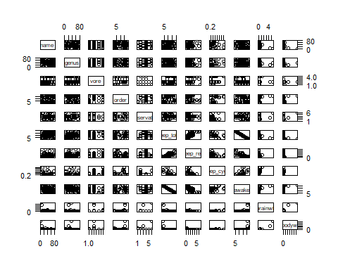 From the plot above I decided to explain more on the corelation between bodywt with vore, brainwt with vore, sleep_total with awake, and bodywt with bodywt.
ggplot(msleep, aes(x = bodywt, y = brainwt)) + geom_point() + labs(title = "Body Weight vs Brain Weight", x = "Body Weight", y = "Brain Weight") + scale_x_log10() + scale_y_log10()
## Warning: Removed 27 rows containing missing values (`geom_point()`).
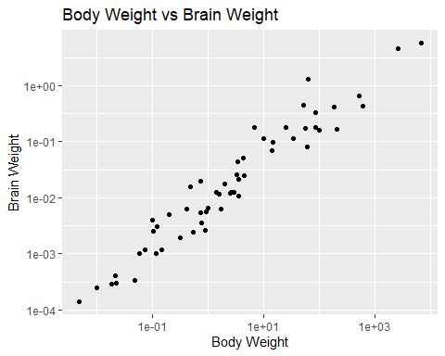 From the Plot above we can see that there’s a postive realtionn between body weight and brain weight thus we can conlude that the heavier an animal is then its brain will also be heavier.
ggplot(msleep, aes(x = sleep_total, y = awake)) + geom_point() + labs(title = "Sleep Total vs Awake Time", x = "Sleep Total", y = "Awake Time")
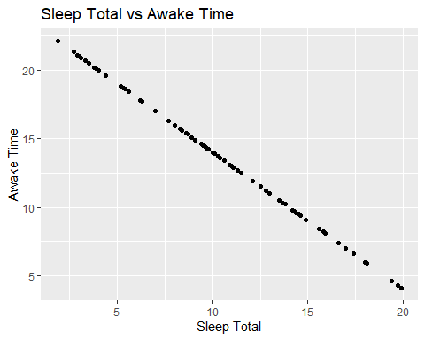 From the plot above we can see that Sleep Total and Awake time have a negative relatiosip. Meaning that the more an animal sleep then it will be awake lesser and vice versa.
ggplot(msleep, aes(x = vore, y = bodywt)) + geom_bar(stat = "summary", fun = "mean") + labs(title = "Body Weight Comparison with Vore Type", x = "Vore", y = "Body Weight" )
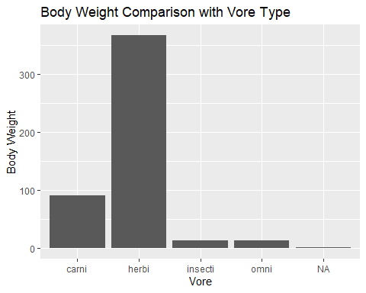 From the Graph above we can see that on average Herbivore have the heaviest body weight with Carnivore following. With Insectivore and Omnivore being the equally the lightest weight out of all.
ggplot(msleep, aes(x = vore, y = brainwt)) + geom_bar(stat = "summary", fun = "mean") + labs(title = "Brain Weight Comparison with Vore Type", x = "Vore", y = "Brain Weight" )
## Warning: Removed 27 rows containing non-finite values (`stat_summary()`).
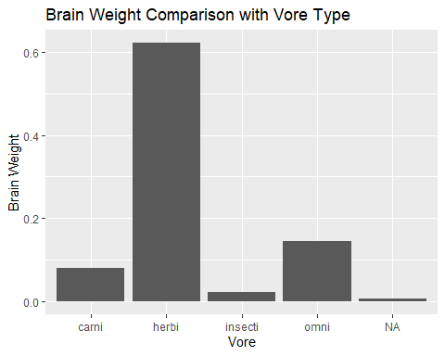 From the graph above we can also see that on average Herbivore having the heaviest brain out of all. WIth Omnivore folloing, having the second heaviest brain on average and Carnivore being the 3rd heaviest brain and insectivore having the lightest brain out of all on average.

Anomalies
User Defined Function to Calculate How many anomalies
extreme_values <- function(data) {
# Calculate the IQR of the variable
iqr <- IQR(data, na.rm = TRUE)
# Calculate the lower and upper bounds for outliers
lower_bound <- quantile(data, 0.25, na.rm = TRUE) - 1.5 * iqr
upper_bound <- quantile(data, 0.75, na.rm = TRUE) + 1.5 * iqr
# Count the number of extreme values
extreme <- data[data < lower_bound | data > upper_bound]
return(extreme)
}
extreme_values(msleep$sleep_total)
## numeric(0)
There’s no Extreme Values in sleep_total Variable
extreme_values(msleep$sleep_cycle)
## [1] NA NA NA NA NA NA NA NA
## [9] NA NA NA NA NA NA NA NA
## [17] NA NA 1.500000 NA NA NA NA NA
## [25] NA NA NA NA NA 1.416667 NA NA
## [33] NA NA NA NA NA NA NA NA
## [41] NA NA NA NA NA NA NA NA
## [49] NA NA NA NA NA
The sleep_cycle Variable has 2 extreme values of 1.5 and 1.416667
extreme_values(msleep$sleep_rem)
## [1] NA NA NA 4.9 NA NA NA 6.6 NA NA NA NA NA NA NA NA NA NA 6.1
## [20] NA NA NA NA NA NA
The sleep_rem Variable has 3 extreme values of 4.9, 6.1, and 6.6.
extreme_values(msleep$awake)
## numeric(0)
The awake Variable has no extreme value.
extreme_values(msleep$brainwt)
## [1] NA NA 0.423 NA NA NA NA 4.603 0.655 0.419 NA NA
## [13] NA 0.325 1.320 NA 5.712 NA NA NA NA NA NA 0.440
## [25] NA NA NA NA NA NA NA NA NA NA NA
The brainwt Variable has 8 extreme values of 0.423, 4.603, and 0.655, 0.419, 0.325, 1.320, 5.712, 0.440.
extreme_values(msleep$bodywt)
## [1] 600.000 2547.000 521.000 187.000 899.995 800.000 6654.000 162.564
## [9] 161.499 207.501 173.330
The bodywt Variable has 11 extreme values of 600.000, 2547.000, 521.000, 187.000, 899.995, 800.000, 6654.000, 162.564, 161.499, 207.501, 173.330.

